THE NATIONAL TRUST

Annual Report
2020-21

List of Members of the Board of the National Trust

S.No. | Name | Address | Contact
1 | Ms. Shakuntala D. Gamlin (Till 31st March 2021)  Now, Ms Anjali Bhawra | Secretary, DEPwD & Chairperson for the Board of the National Trust, MSJE, Govt. of India, 16 B, Bada Bazar Road, Old Rajinder Nagar, New Delhi | secretaryda-msje@nic.in  011-24369055
2 | Mr. Nikunja K Sundaray (Upto 11/10/2020) | JS & CEO, National Trust, MSJE, Govt. of India , 16B, Bada Bazar Road, Old Rajinder Nagar, New Delhi | js_ceo_nt@thenationaltrust.in  011-43187801
3 | Mr. Sanjay Pandey | FA, Ministry of Social Justice & Empowerment, Room No. - 609-A, Shastri Bhawan,  New Delhi-110001 | s_pandey@gov.in  011-23387924/23073598
4 | Mr. Kishor B.Surwade, ISS  (From 12/10/2020) | Deputy Director General, DEPwD and JS&CEO, NT (Addl. Charge), Room No. 514, (B-II), M/o SJ&E, Antyodaya Bhawan, CGO Complex, Lodhi Road, New Delhi | ddg-depwd@gov.in  011-24364394
5 | Sh Santosh Kumar Yadav | Joint Secretary,Deptt. Of School Education & Literacy), M/o Education  Shastri Bhawan,  New Delhi | Yadavsk.up@nic.in  011-23387781
6 | Dr. N. Srinivasa Rao | Economic Advisor (NSAP & IT)  M/o Rural Development, Krishi Bhavan, New Delhi | Srinivas.rn@nic.in  011-23386411
7 | Mr. Shivdas Meena | Joint Secretary (UD), Ministry of Urban Development, Nirman Bhawan, Maulana Azad Road, New Delhi-110108 | mshivdas@ias.nic.in  011-23062477
8 | Ms. Vibha Bhalla | JS, Social Security Division, M/o Labour & Employment, Room No.106, Shram Shakti Bhawan  Rafi Marg.  New Delhi-110001 | v.bhalla@nicin  011-23710239
9 | Ms. Aastha Saxena Khatwani | Joint Secretary, M/o Women and Child Development, Shastri Bhawan, New Delhi | aastha.khatwani@nic.in  011-23388576
10 | Mr Lav Agarwal, | Joint Secretary, Ministry of Health & Family Welfare, Nirman Bhavan, New Delhi | alav@ias.nic.in  011-23061195
11 | Ms. Uma S. Seth, | Additional Director (Team Lead for FICCI CSR), FICCI, Federation House, Tansen Marg, New Delhi - 110 001 | uma.seth@ficci.com  011-23357243  9899324304
12 | Mr. Jignesh Joshi | Representative of ASSOCHAM, CEO, JMPC Builtline Pvt Ltd 904-905, President House Opp: C.N. Vidhyalaya, Ambawadi, Ahmedabad – 3800015 | jignesh.joshi@jmpcbuiltline.com  079-26422432  09898989444
13 | Mr. Gopal Singaraju | Member, Confederation of Indian Industry (CII), National Committee on Special Abilities & Chief Operating Officer - Royal Bank of Scotland, 2-B, Block-B, Raintree Appartment , No 21 Venus Colony, Lind Street Cross, Alwarpete - 600018, Chennai | gopal.singaraju@rbs.com  9840790120

14 | Mr. Abhay Kumar Dubey | 131, Indrapuri Colony Gwarighat Road, Jabalpur - 482008, Madhya Pradesh | abhaydubeyjbp@gmail.com  9425150672
15 | Ms. Ruby Singh | C/O Col PK Singh, #5/4, Vannerpet Officers Colony, Old Race Course Road, Austin Town, Bangalore - 560047 | alfaa2010@gmail.com; rubysingh.pms@gmail.com 9741418103
16 | Dr. Sapam Jasowanta Singh | 57, Sagolband Tera Pukhri Mapal lmphal West, Imphal - 795001, West Manipur | hdfoundationmanipur@gmail.com; sapamjasowanta2399@gmail.com 9612157246
17 | Mrs. Pooja Sureshbhai Vaghasiya | Rajan, Shivsrushhti - 2, Pedak Road, Bhind Bharatiy School, Rajkot – 360003 | patelridhi007@gmail.com 8128138092
18 | Mr. Guriqbal Singh Bedi | 5, Hargobind Nagar Sarhing Road, Patiala - 147004, Punjab | membernationaltrust@gmail.com; presidentautismindiatoday@gmail.com 9356767367 / 9417686400
19 | Dr. Ashish Kumar | S/O Janadeo Singh, Block B Swastik Enclave, Flat No. 2A, Buxi Bazar, Cuttak Sadan, Odisa – 753001 | ashish_ashtha@rediffmail.com 9338128085
20 | Mr. Pushp Pal Singh | C-47 Rajender Nagar Bareilly, Izzat Nagar UP | designviews540554@gmail.com; 9568181368 / 9412288074

List of Permanent and Contractual Staff of the National Trust

Sl.No. | Name | Designation
 | Shri U.K. Shukla | Programme Director
 | Shri Navnit Kumar | Deputy Director
 | Sh Amit Kumar Ashutosh | Accounts Officer
 | Shri S.K. Thukral | P.S.
 | Smt. Sushma Ghai | P.S.
 | Smt. Shreshtha Sahni | P.A.
 | Shri Amitabh Trivedi | Accountant
 | Smt. Monika Wadhwa | Assistant
 | Smt. Vandana Chopra | Program Associate
 | Ms Muskan Khullar | Program Associate
 | Shri B.S. Negi | U.D.C.
 | Shri Rambilas Rajbhar | M.T.S.
 | Smt. Rekha Mamgain | M.T.S.
 | Shri Ram Ashish Gaur | M.T.S.

On contract
Sl. No. | Name | Designation
 | Shri Jasvinder Pal Singh Khera | Accounts Assistant
 | Shri Tilak Raj | Office Assistant
 | Smt. Pushpa Pandey | Office Assistant
 | Smt. Anita Rani | Office Assistant
 | Shri Guddu | Safai Karamchari

Introduction

The National Trust is a statutory body constituted by an Act of Parliament namely The National Trust for the Welfare of Persons with Autism, Cerebral Palsy, Mental Retardation and Multiple Disabilities Act, 1999.
As per Section 10, the objectives of the National Trust are as follows :-
- To enable and empower persons with disability to live as independently and as fully as possible within and as close to the community to which they belong;
- To strengthen facilities to provide support to persons with disability to live within their own families;
- To extend support to registered organizations to provide need based services during period of crisis in the family of persons with disability;
- To deal with problems of persons with disability who do not have family support;
- To promote measures for the care and protection of persons with disability in the event of death of their parent or guardian;
- To evolve procedures for the appointment of guardians and members for persons with disability requiring such protection;
- To facilitate the realization of equal opportunities, protection of rights and full participation of persons with disability; and
- To do any other act which is incidental to the aforesaid objects.

The National Trust has been set up to discharge two basic duties- legal and welfare. Legal duties are discharged through Local Level Committees and providing Legal Guardianship. Welfare duty is discharged through the Schemes implemented by the Registered Organisations. The activities of the National Trust inter-alia include training, awareness and capacity building programmes and shelter, care giving and empowerment. The National Trust is committed to facilitate equal opportunities, protection of rights and full participation of persons with disabilities (Divyangjan), covered under the Act.

Local Level Committee
Under Section 13 of the National Trust Act 1999, a Local Level Committee is required to be constituted in every district of the country for a period of three years or till it is reconstituted by the Board consisting of following members:-
- An officer of the Civil Service of the Union or of the State not below the rank of District Magistrate or a District Commissioner of a District;
- A representative of an organization registered with the National Trust; and
- A person with disability as defined in Clause (t) of Section 2 of the Persons with Disabilities Act, 1995(1 of 1996)
The function of Local Level Committee is to screen, appoint, monitor and remove legal guardians. LLCs also promote activities such as Awareness generation, convergence and mainstreaming of persons with disabilities.
In order to make Local Level Committee more accountable, the online process for functioning of Local Level Committees was started. The Login ID and password of all the DC/DMs/LLC Chairperson, were sent, to enable them to start online processing of Legal Guardianship cases. For LLC membership, the NGO (registered with the National Trust) and Person with Disability member have to apply online and after uploading the required documents they can submit the application. The Constitution / Reconstitution Order can be downloaded after the approval of the Competent Authority of the National Trust.
* So far, 694 LLCs have been constituted covering all the districts of the country (excluding UTs of Jammu & Kashmir and Ladakh)
The Local Level Committees in the Districts of Jammu & Kashmir and Ladakh were constituted in 2021-22 after abrogation of Article 370 and inclusion of the UTs in the National Trust Act, 1999 thereby making it applicable to the entire country now.
In many districts of the country NGOs registered with National Trust are not available. In those cases where recommendation from the District Collector/Magistrate is not available with the registered organization or person with disability, the SNACs have been authorized vide meeting dated 22nd October 2019, to issue such recommendation letter for 2nd and 3rd member of the Local Level Committee. The State Nodal Agency Centers have been authorized to recommend LLC-NGO member for those districts also where no Registered Organisation exist. They can recommend neighboring RO for the purpose.
The SNACs can also recommend the Divyangjan Member as third member for LLC.
Even the mandatory requirement of submission of LLC Bank Account Detail has been waived while filling online form for inclusion in LLC by the NGO member and Divyangjan member. But the Registered Organisations and Divyangjan who become LLC Member must expedite the process of opening of LLC Bank Account with DC office. In its absence whatsoever funds disbursed to LLC for activity based functioning as per funding pattern can’t be released.

Appointment of Legal Guardians

- Section 14-17 of The National Trust Act, 1999 elaborates on Guardianship for persons with Autism, Cerebral Palsy, Mental Retardation and Multiple Disabilities, to be, given by the Local Level Committee. Guardianship is a need based enabling provision.
- A guardian is a person, who is, appointed to look after another person or his property or both. He or she assumes the care and protection of the person for whom he/she, is appointed the guardian. The guardian takes all legal decisions on behalf of the person and the property of the ward.
- Persons with Autism, Cerebral Palsy, Mental Retardation and Multiple Disabilities are in a special situation as even after they have acquired 18 years of age, they may not always be capable of managing their own lives or taking legal decisions for their own betterment. Therefore, they may require someone to represent their interests in the legal areas throughout their lives. However, in cases of cerebral palsy and multiple disabilities, there may be a need for only limited guardianship because of the availability of enabling mechanisms and/ or scientific facilitations, which enable such persons to function with varying degrees of independence.
- Under section 14 of the National Trust Act, the Local Level Committee headed by the District Collector is empowered to receive application in Form A under Rule 16(1) and appoint guardians in Form B under Rule 16(2) for persons with Autism, Cerebral Palsy, Mental Retardation & Multiple Disabilities. It also provides mechanism for monitoring and protecting their interests including their properties. All these forms are built in the online Legal Guardianship Module.
- In the year 2020-2021, 4377* Legal Guardianship applications are approved and verified.
* Disclaimer: - The above figure is as on 31st March 2021 from Scheme Management System. It may change as per decision of the Local Level Committee if any case is reviewed.

Registration of Organizations (ROs)

I As per section 12(1) of the National Trust Act, any Voluntary Organization, Association of Parents of Persons with Disabilities and Association of Persons with Disabilities working for the empowerment of persons with Autism, Cerebral Palsy, Mental Retardation and Multiple Disabilities registered under the Societies Registration Act, 1860(21 of 1860) or Section 25 of the Companies Act, 1956(1 of 1956) or as a Public Charitable Trust can apply for registration subject to the condition that they are registered under -
  - Persons With Disability Act, 1995/Rights of Persons with Disability Act-2016 in the concerned State
  - NGO Darpan Portal of Niti Aayog
The registration of such organization shall be necessary with the National Trust for availing benefits under the schemes of the National Trust.

II On the website of the National Trust the entire process right from applying to processing and approving or rejecting is online. Registration fee need to be deposited electronically. The NGOs have to upload all the documents with the on-line application. The entire process of registration is not only on-line but also transparent. Registration of Organizations is open throughout the year.

During the year 2020-21, 92 Organizations registered online and the total number of Registered Organisations is 668. State-wise and District-wise list of Registered Organizations are available on the website.

State Nodal Agency Centre (SNAC)

In order to carry out the activities of the National Trust, its effective implementation at the state level and for coordination/liaison with the concerned State Government Departments, a reputed Registered Organization of the National Trust is appointed as State Nodal Agency Centre (SNAC). The National Trust provides funds for conducting institutional activities namely meetings of Registered Organizations / Local Level Committee(LLCs), State Level Coordination Committees (SLCCs), documentation / Reporting, honorarium for coordinator, misc. activities. At present there are 27 SNACs in the country. The list of all State Nodal Agency Centres (SNACs) is available on the website and placed as Annexure.
During the year 2020-2021, an amount of Rs. 44.16 lakh has been released to the SNACs.

State Level Coordination Committee (SLCC)

Every State Government/UT Administration has been requested to set up a State Level Coordination Committee (SLCC) for effective implementation and monitoring of the schemes of the National Trust. The Secretary of the State Government looking after disability affairs is the Chairperson and the respective SNAC is the convener of the Committee. The Composition of SLCC is as under:-
Secretary, Social Welfare---------------Chairman
Commissioner (Disabilities)------------Vice-Chairman
Director, Social Welfare-------------------Member
State Nodal Agency Center---------------Member Secretary
1 LLC NGO Member ------------------------Members
(from every 10 districts)
So far, SLCCs have been constituted in 29 States / Union Territories.

The Schemes highlights and the fund released to various project holders:

Disha (Early Intervention and School Readiness Scheme for 0-10 years)
This is an early intervention and school readiness scheme for children in the age group of 0-10 years with the four disabilities covered under the National Trust Act and aims at setting up Disha Centres for early intervention for Persons with Disabilities (Divyangjan) through therapies, trainings and providing support to family members. The project holders should provide day-care facilities to PwDs (Divyangjan) for at least 4 hours in a day (between 8 am and 6 pm) along with age specific activities. There should be a Special Educator or Early Intervention Therapist, Physiotherapist or Occupational Therapist and Counsellor for PwDs (Divyangjan) along with Caregiver and Ayas in the centre.

115 Disha Centers have been sanctioned benefiting 3588 beneficiaries during the last 6 years in the country. In 2020-21, 491 beneficiaries benefitted through 30 Disha Centres. Under the scheme, an amount of Rs. 1199.61 Lakh has been released, so far. This includes release of Rs.208.82 Lakh during 2020-21.

VIKAAS (Day Care Scheme for 10+ years)

This is a Day care scheme for Divyangjan attaining the age of 10 years and above, primarily to expand the range of opportunities available to a person with disability for enhancing interpersonal and vocational skills as they are on a transition to higher age groups. The centre offers care giving support to Persons with Disabilities (Divyangjan) during the time the Divyangjan are in the Vikaas centre. In addition, it also helps in supporting family members of the Persons with disabilities covered under the National Trust Act to get some time during the day to fulfil other responsibilities. Project Holders should provide day-care facilities to Divyangjan for at least 6 hours in a day (between 8 am and 6 pm) along with age specific activities. Day care should be opened for at least 21 days in a month.
124 Vikaas Centers have been sanctioned benefiting 5665 beneficiaries during the last 6 years in the country. In 2020-21, 790 beneficiaries benefitted through 33 Vikaas Centers. Under the scheme, an amount of Rs.1987.41 Lakh has been released, so far. This includes release of Rs. 347.61 Lakh during 2020-21.

Disha-cum Vikaas Scheme (Day Care)

For the Registered Organisations, who were implementing multiple schemes, an option for implementing merged scheme was given. Based on the consent given by the ROs and the scheme guidelines, 41 ROs were allotted the merged Disha-cum-Vikaas Scheme (Day Care) w.e.f. 1.4.2018.
There are 41 Disha-cum-Vikaas Centers benefiting 3303 beneficiaries during the last 3 years in the country. This includes 1325 beneficiaries during 2020-21. Under the scheme, an amount of Rs.1430.56 Lakh has been released, so far. This includes release of Rs. 714.08 lakh, during 2020-21.

Samarth (Respite Care Residential Scheme)

The objective of Samarth scheme is to provide respite care home for orphans or abandoned, families in crisis and also for Persons with Disabilities (Divyangjan) from BPL & LIG families including destitute with at least one of the four disabilities covered under the National Trust Act. The scheme provides for creating opportunities for family members to get respite time in order to fulfil other responsibilities. Under the Scheme Samarth Centres are set up for providing group home facility for all age groups with adequate and quality care service with acceptable living standards including provision of basic medical care from professional doctors.
45 Samarth Centers have been sanctioned benefiting 1621 beneficiaries during the last 6 years in the country. In 2020-21, 160 beneficiaries benefitted through 10 Samarth Centers. Under the scheme, an amount of Rs. 920.42 Lakh has been released, so far. This includes release of Rs.134.63 Lakh during 2020-21.

Gharaunda (Group Home for Adults)

The objective of Gharaunda scheme is to provide an assured home and minimum quality of care services throughout the life of the persons with Autism, Cerebral Palsy, Mental Retardation and Multiple Disabilities. The scheme also facilitates establishment of requisite infrastructure for the assured care system throughout the country, encourage assisted living with independence and dignity and provide care services on a sustainable basis.
50 Gharaunda Centers have been sanctioned benefiting 1275 beneficiaries during the last 6 years in the country. In 2020-21, 275 beneficiaries benefitted through 20 Gharaunda Centers. Under the scheme, an amount of Rs.1445.23 Lakh has been released, so far. This includes release of Rs.322.53 Lakh during 2020-21.

Samarth-cum-Gharaunda Scheme (Residential)

For the Registered Organisations, who were implementing multiple schemes, an option for implementing merged scheme was given. Based on the consent given by the ROs and the scheme guidelines, 12 ROs were allotted the merged Samarth-cum-Gharaunda Scheme (Residential) w.e.f. 1.4.2018.
There are 12 Samarth-cum-Gharaunda centers benefiting 643 beneficiaries during the last 3 years in the country. During 2020-21, 283 beneficiaries have been benefitted by these 12 Samarth-cum-Gharaunda centres. Under the scheme, an amount of Rs. 443.69 Lakh has been released, so far. This includes release of Rs. 242.24 Lakh during 2020-21.

Badhte Kadam (Awareness, Community Interaction & Innovative Project Scheme)

This scheme supports Registered Organisations (ROs) of the National Trust to carry out activities that focus on increasing the awareness about the disabilities covered under the National Trust. Aim of the scheme is to create community awareness, sensitization, social integration and mainstreaming of Persons with Disabilities (Divyangjan). The National Trust can sponsor maximum of 4 events for each Registered Organization per year. Each Registered Organization should conduct at least one event either for community, educational institutes or medical institutes, in a year. The proposal received from Registered Organisations covered under “Sampark-In the Hour of Need” Scheme are also considered under Badhte Kadam Scheme.
Under the scheme, 126 Registered Organizations (ROs) have been sanctioned during last 6 years in the country. An amount of Rs. 1.28 Lakh has been released, so far.

‘Niramaya’ Health Insurance Scheme
The scheme is to provide affordable Health Insurance to persons with Autism, Cerebral Palsy, Mental Retardation and Multiple Disabilities. The enrolled beneficiaries get a health insurance cover upto Rs.1.0 lakh, by paying a nominal enrollment/renewal fee, as per details given below :-
Fee Chart : The Complete Fee chart for enrolment and renewal under Niramaya Health Insurance Scheme, applicable from 1st April 2016 is as under:-

Enrolment and Renewal Fee
PwD Category | Enrolment Fee (In Rs) | Renewal Fee (In Rs.)
Below Poverty Line(BPL) | Rs. 250/- | Rs. 50/-
Non BPL | Rs. 500/- | Rs. 250/-
PwD with Legal Guardian (Other than natural parents) | Free | Free

The Heads under which the beneficiary can avail the benefit (The Benefit Chart) is as follows:

‘Niramaya' Health Insurance Scheme - Revised Benefit Chart
(On Reimbursement Basis only w.e.f. April, 2015)
Section | Sub- Section |  | Detail |  | Sub-Limit | Over all Limit of Section
I | Over all Limit of Hospitalization |  |  |  |  | 70,000/-
 | A |  |  | Corrective Surgeries for existing Disability including congenital disability | 40,000/-
 | B |  |  | Non- Surgical/ Hospitalization | 15,000/-
 | C |  |  | Surgery to prevent further aggravation of disability | 15,000/-
II | Overall Limit for Out Patient Department (OPD) |  |  |  |  | 14,500/-
 | A | OPD treatment including the medicines, pathology, diagnostic tests, etc. |  |  | 8,000/-
 | B | Regular Medical checkup for non-ailing disabled |  |  | 4,000/-
 | C | Dental Preventive Dentistry |  |  | 2,500/-
III | Ongoing Therapies to reduce impact of disability, disability and disability related complications |  |  |  |  | 10,000/-
IV | Alternative Medicine |  |  |  |  | 4,500/-
V | Transportation costs |  |  |  |  | 1,000/-
OVERALL LIMIT OF THE COVERAGE FOR A PERSON: Rs.1,00,000/-

During the year 2020-2021, 174979 beneficiaries have been enrolled. Total 13096 claims are settled. The expenditure during the year is Rs. 8.81 crore. At present, the scheme is being implemented through M/s. Oriental Insurance Co. Ltd.
On the long standing demand of the parents/guardians of divyangjan, an important provision has been made in the Scheme Management System wherein renewal under Niramaya Health Insurance Scheme can be done directly by them and they are not required to approach Registered Organisation(RO) for the purpose. However, if they still wish to move through RO, the same also can be done.
A major decision taken by the Board of the National Trust in respect of this scheme is that Registration fee of RO’s for enrolment of beneficiaries has been waived off under Niramaya Health Insurance Scheme so that more and more organizations can avail this scheme for the benefit of Divyangjan.

9.9 Sahyogi (Care Associate Training scheme)

This scheme aims at setting up Care Associate (Caregiver) Cells (CACs) to provide training and create a skilled workforce of Care Associates to provide adequate and nurturing care for Persons with Disabilities (Divyangjan) and their families who require it. It also seeks to provide parents an opportunity to get trained in care giving, if they so desire. This scheme will provide a choice of training through two levels of courses primary and advanced to allow it to create care associates suited to work both with Persons with Disabilities (Divyangjan) families and other institutions catering to the needs of the Divyangjan (NGOs, work centres etc.).

There are 56 Care givers training Centers set up under the Sahyogi Scheme in which 1762 Care givers trained during the last 6 years in the country. Under the scheme, an amount of Rs. 179.81 Lakh has been released, so far.
At present the scheme is open for the North-Eastern States only.
10 Implementation of Revised Schemes of National Trust w.e.f. 1st April, 2018

As approved in the 77th meeting of the Board of the National Trust held on 20th March 2018, the National Trust has started implementation of revised schemes w.e.f. 1st April 2018. Details of this is as under:
- In case of implementation of multiple schemes by a RO, the two schemes namely Disha and Vikaas will be merged as a single scheme namely Disha-cum-Vikaas. Similarly, Samarth and Gharaunda will be merged in a single scheme namely Samarth-cum-Gharaunda. In no case, the Registered Organisations (ROs) will be sanctioned more than one scheme at a time.

Details of the structure of these schemes will be as under :
Sl.  no. | Existing Scheme | Existing |  | Revised Structure | Structure
Sl.  no. | Existing Scheme | Set up cost (Rs.) | Monthly Recurring fund (Rs.) | Revised Structure | Set up cost (Rs.) | Monthly Recurring fund (Rs.) | Staff required
1 | Disha (Early Intervention & School Readiness Scheme) | 1.55 lakh | 4,500/- | Disha-cum-  Vikaas Scheme  (batch size 40) | 1.55 lakh | Rs.3500/-  (Rs.3000/- + conveyance @ Rs.500/- p.m. per eligible bnf.) upto maximum for 30 eligible BPL benef. Ratio condition will remain same as per the guidelines. | (1) Early Intervention Therapist /  OT/ PT : any two  (2) Sp Educator /  Voc Trainer : any One  (3) Counsellor :  3 times a week  (4) Caregiver : 02  (5) Aaya : 02
2 | Vikaas (Day Care for 10+ years Scheme) | 1.95 lakh | 4,850/-
3 | Samarth (Respite Care Residential Scheme) | 2.90 lakh | 7,000/- | Samarth-cum Gharaunda (Residential Care) Scheme  (Batch size 30) | 1.90 lakh | Rs. 5,000/-  upto maximum for 20 eligible BPL benef. | (1) OT : 01  (2) PT : 01  (3) Sp Educator /  Voc Trainer : any One  (4) Caregiver : 03  (5) Aaya : 02  (6)Cook : 01
4 | Gharaunda (Group Home for Adults) | 2.90 lakh | 10,000/-
5 | Niramaya (Health Insurance Scheme) same as it is
6 | Sahyogi (Caregiver training scheme) | 1.00 lakh | 1)Trainee cost :  - Primary: Rs.4200  - Advance: Rs.8000  2) Trainee stipend - Primary: Rs.5000  - Advance: Rs.10000 |  | 50,000/- | 1)Trainee cost  (Primary- 2000 & Advanced –Rs. 3000)  2) Trainee stipend  (Primary-3000 & Advanced-5000)
7 | Gyan Prabha (Educational support) |  |  |  | Scheme closed as similar scheme is being implemented by DEPwD, M/O SJE
8 | Prerna (Marketing Assistance) |  |  |  | Scheme to be revised
9 | Sambhav (Aids and Assisted Devices) |  |  |  | Scheme to be revised
10 | Badhte Kadam (Awareness, Community Interaction and Innovative Project) |  |  |  | Only 1 program to each RO in a financial year

No New sanction under any scheme of the National Trust shall be made till further decision of the Board or sub-committee constituted especially for this to take a decision. However, this will not be applicable for North Eastern States and for the ROs implementing Old GHARAUNDA scheme into revised Gharaunda Scheme, as per the plan already approved by the Board. This will also not be applicable for awareness programmes on inclusive india initiative, organized under Badhte Kadam Scheme on direction of the National Trust.
The ROs will be allowed to implement only one type of scheme i.e. Day Care (Disha cum Vikaas Scheme) or Residential Care (Samarth cum Gharaunda Scheme). This will be applicable for the existing scheme holders also.
From the financial year 2018-19, for the existing scheme holders (ROs), implementing single schemes from the four center based schemes, namely Disha, Vikaas, Gharaunda and Samarth, the funding pattern will be as follows:-
(a) The Monthly recurring fund will be Rs.3000/-+Rs.500 (Transport Allowance) per beneficiary, per month, under Disha and Vikaas Schemes and Rs.5000/- per beneficiary, per month under Gharaunda and Samarth Schemes.
(b) The no. of beneficiaries will remain same as in the scheme guidelines i.e Disha-20, Vikaas-30, Gharaunda-20, and Samarth-30.
© The maximum no. of BPL beneficiary funded by National Trust will be limited to 20 BPL beneficiaries for Disha and Vikaas Schemes and 15 BPL beneficiaries for Samarth and Gharaunda Schemes.
(d) In no case, the ROs will be sanctioned more than one scheme at a time.
(e) This is issued with the prior approval of the competent authority of the Board of the National Trust.

11 Restoration of Initial Funding Pattern
1. The Board of the National Trust has approved restoration of initial funding pattern under Disha, Vikaas, Disha cum Vikaas, Samarth, Gharaunda and Samarth cum Gharaunda Scheme w.e.f 1.04.2020 as per following details:-
Sl. No. | Scheme | Amount - per Beneficiary | Transportation Charges | Total Beneficiary per centre
I | Disha (Early Intervention & School Readiness) Scheme | 4500/- | 1000/- | 20
Ii | Vikaas (Day Care) Scheme | 3850/- | 1000/- | 30
Iii | Samarth (Residential) Scheme | 7000/- | - | 30
Iv | Gharaunda (Group Home for Adults) Scheme | 10000/- | - | 20
V | Disha-cum-Vikaas (Day Care) Scheme (including transportation charges of Rs.1000/- per benef.) | 4200/- | 1000/- | 30
Vi | Samarth-cum-Gharaunda (Residential) Scheme | 8500/- | - | 30

2. Based on this arrears of the fund w.e.f 01.04.2020 has been worked out.
The arrears will be released offline and entry of the arrears released will be made in the online scheme management system at the time of release of next monthly grant.
The following decisions were also taken from the year 2018-19 which are applicable during the current reporting period also:-
Schemes/programmes are not sanctioned presently. Only running projects are continued. This condition does not apply to the North-Eastern States and for the ROs implementing old GHARAUNDA Scheme. The revised Gharaunda Scheme is to be sanctioned in order to adjust the old GHARAUNDA Scheme into revised Gharaunda Scheme, as per the plan already approved by the Board.
Any Registered Organisation can implement only one scheme/programme at a time. Accordingly, apart from singly Disha, Vikaas, Samarth and Gharaunda, there are merged centers also namely:- Disha cum Vikaas and Samarth cum Gharaunda.
11 Implementation of “Sampark – in the hour of need” scheme in Odisha and West Bengal

The National Trust has launched Sampark- ‘In the Hour of Need’ scheme from 1st November, 2019 for 100 days in the 5 districts of Odisha namely - Puri, Khurda, Cuttack, Kendrapade and Jagatsinghpur due to Super Cyclone ‘FANI’. Later on, the scheme was extended to 5 more districts of Odisha namely- Ganjam, Jajpur, Bhadrak, Baleswar and Mayurbhanj and 13 districts of West Bengal namely- South 24 Parganas, North 24 Parganas, Howrah, Kolkata, Purba Mediipur, Paschim Medinipur, Nadia, Hoogly, Purba Bardhaman, Paschim Bardhaman, Birbhum, Murshidabad and Malda due to other super cyclones ‘BULBUL and AMPHAN '.
Under the scheme, need assessment of beneficiaries and enrolment under Niramaya scheme and providing other benefits of the National Trust and other State & Central government schemes are covered. Details guidelines of the scheme, list of the districts covered under the scheme, list of registered organisations of the National Trust implementing the scheme in the two states and operational guidelines of the scheme have been made and circulated to the Registered Organisations implementing the scheme. The objective of the scheme is to provide necessary support to Divyangjan covered under the National Trust Act in case of natural calamity like – Cyclone, Earthquake, Flood etc. for a period of 100 days, to commence from the first day of each programme. The scheme was started from 1st November, 2019 for a period of 100 days. The scheme was extended 4 times and the last extension ended on 14-3-2021. In case of any further calamity, the scheme will be implemented there, as per the need.

12. Work done during COVID-19 vis a vis various Policy Decisions

The National Trust took various major steps for the welfare of persons with Autism, Cerebral Palsy, Mental Retardation and Multiple Disabilities in combating with COVID-19 pandemic. In this regard, the National Trust issued guidelines and advisory to all its project holders and Registered Organizations (ROs) on how to reach out to the beneficiaries and their parents in the situation of lockdown due to COVID-19. One of the Major initiatives done by the National Trust during the lockdown period are as under -

- The National Trust is implementing centre based schemes namely- Disha (Early Intervention and School Readiness scheme for 0-10 years), Vikaas (Day Care scheme for 10+ years), Samarth (Respite Care scheme) and Gharaunda (Group Home for Adults). In view of the lockdown in the country from the last week of March, 2020, most of the beneficiaries stayed back to their home and do not attend the scheme centres. However, the project holders continued their services to the beneficiaries by doing online counselling to the parents / beneficiaries and providing them required support. Keeping in view of these, the Board of the National Trust had decided to fund all the project holders on the existing rate on the basis of actual number of beneficiaries present in the Center in March 2020, before the lockdown for the entire period of the lockdown.

- The National Trust had issued guidelines for all its Registered Organisations and scheme holders to help, support and provide services to Divyangjan through whatsApp, meeting apps and all innovative means along-with following the COVID protocol. The scheme holders have been asked to submit funding request after submitting proof like photographs of visiting homes of the beneficiaries, report on providing various services etc.

- The National Trust released its 3rd issue of E-Newsletter focussing on COVID19, so that people become aware about its symptoms, cure and prevention to fight the pandemic. The E-newsletter contained articles from WHO guidelines on COVID-19 and the initiatives undertaken by the registered organisations of the National Trust.

- The National Trust organised Webinar Meetings from 1st June 2020 to 24th June, 2020, each day, covering one or two States/ UTs taking all issues related to implementation of Programmes & Schemes, especially during Covid-19 period, Registration and Renewal of ROs, Issuance of Certificates (if any), addressing Grievance etc. with State Nodal Agency Centres (SNAC), Registered Organizations of all States/UTs. The Webinar was also attended by State Government Officials of concerned departments. The National Trust is taking follow-up action on the issues raised in the Webinar.

- The National Trust in collaboration with Aastha Welfare Society, Patna has organized a Zoom meeting on `Roles of the Registered Orgainzations of the Divyangjan covered under the National Trust Act during COVID-19 on 16-5-20 in which the Commissioner, Persons with Disabilities, Bihar, Sh. Anand Kumar, founder of Super 30 and officials of the National Trust participated .

- The National Trust received an information that Mr. Javed, a person with intellectual disability ran away from his house in Mayur Vihar, Delhi. After a gap of several days, he was found in Amritsar, Punjab. Soon after hearing the information, the National Trust contacted its State Nodal Agency Centre (SNAC) in Punjab namely Navchetna Society, Hoshiarpur to track and gain information about Mr. Javed. The SNAC immediately contacted the Police and the district administration of Amritsar. With the collective efforts of the Police and district administration, Mr. Javed was brought back to Delhi from Amritsar and handover to his parents.

13. Annual General Meeting 2020

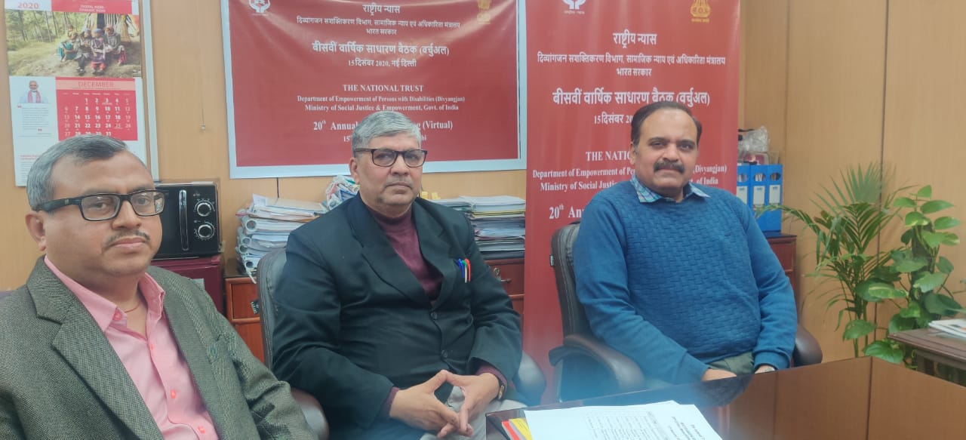
The 20th Annual General Meeting of the National Trust was held on 15th December 2020 through Virtual Mode under the Chairpersonship of Ms. Shakuntala D. Gamlin, IAS, the then Chairperson, National Trust and Secretary, DEPwD. In all there were 331 stakeholders who participated in the AGM.

The Chairperson acknowledged there is a dearth of rehabilitative professionals in the country. Being Chairperson RCI, she shared various steps being taken to facilitate increase in number of rehabilitative professionals like restructuring of the RCI courses designing of a universal curriculum so that rehabilitative experts in close coordination with their medical counterparts can improve early intervention services in the country. She wished the National Trust a great success in terms of its work, content and quality. State Nodal Agency Centres (SNAC) from Tamil Nadu and West Bengal presented the best practices followed during COVID-19.
During the open session various queries were answered by the then JS&CEO, National Trust and Programme Director, National Trust.

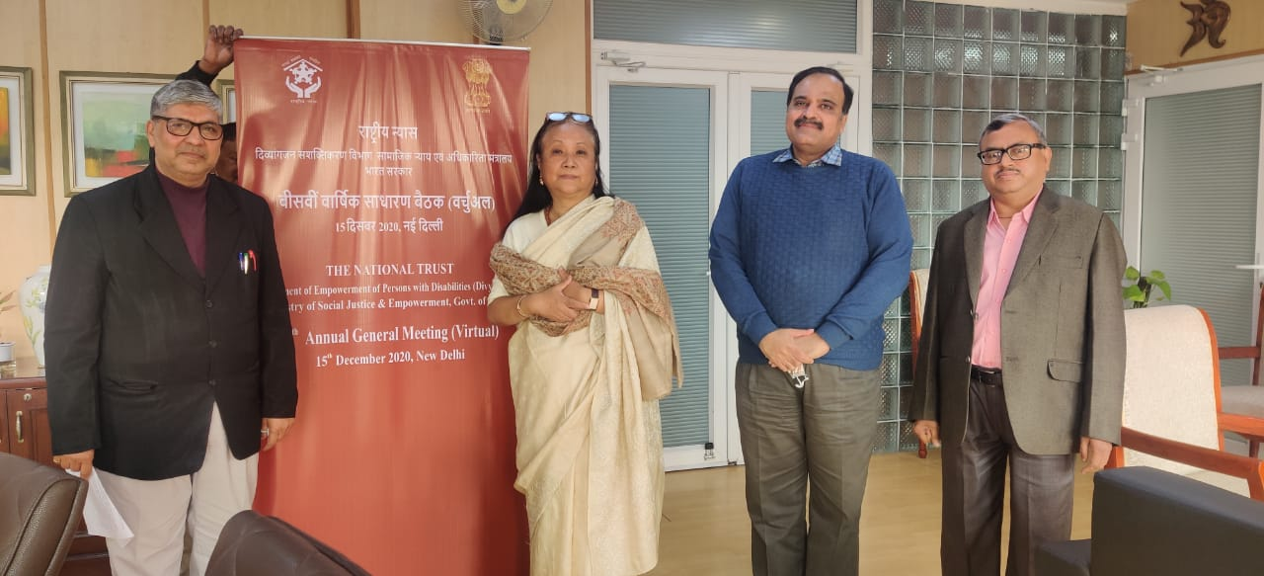

14. Other Activities and various Conferences and Workshops of the National Trust

14.1 Virtual Meetings
After May/June 2020, Virtual Meeting with Registered Organisations and State Nodal Agency Centers were organized in January 2021 wherein issues concerning each State were discussed and issues resolved there and then.
Further new organizations became State Nodal Agency Center in January 2021, hence an introductory meeting was held on 9th February 2021. They were requested to organize meetings with the Registered Organizations of their States/UTs in which National Trust also participated. These meetings were conducted in March 2021. One of the objectives of the meeting was to request all Registered Organisations to start helping Divyangjan in enrollment under Niramaya Health Insurance Scheme and facilitate parents/guardians of Divyangjan in filling online Legal Guardianship form.

14.2 Grievance Redressal
The grievances received in the PG Portal to Govt. of India have been redressed timely. Apart from this, grievances received through other modes are also been redressed.

14.3 National Trust Act Amendment
The major work related to Amendment to National Trust Act, 1999 was completed in 2019-2020, however after fine tuning it was finally submitted to the Deptt. Of Empowerment of Persons with Disabilities (Divyangjan) in August 2020.

14.4 Purchase and Distribution of Teaching Learning Material (TLM) Kits
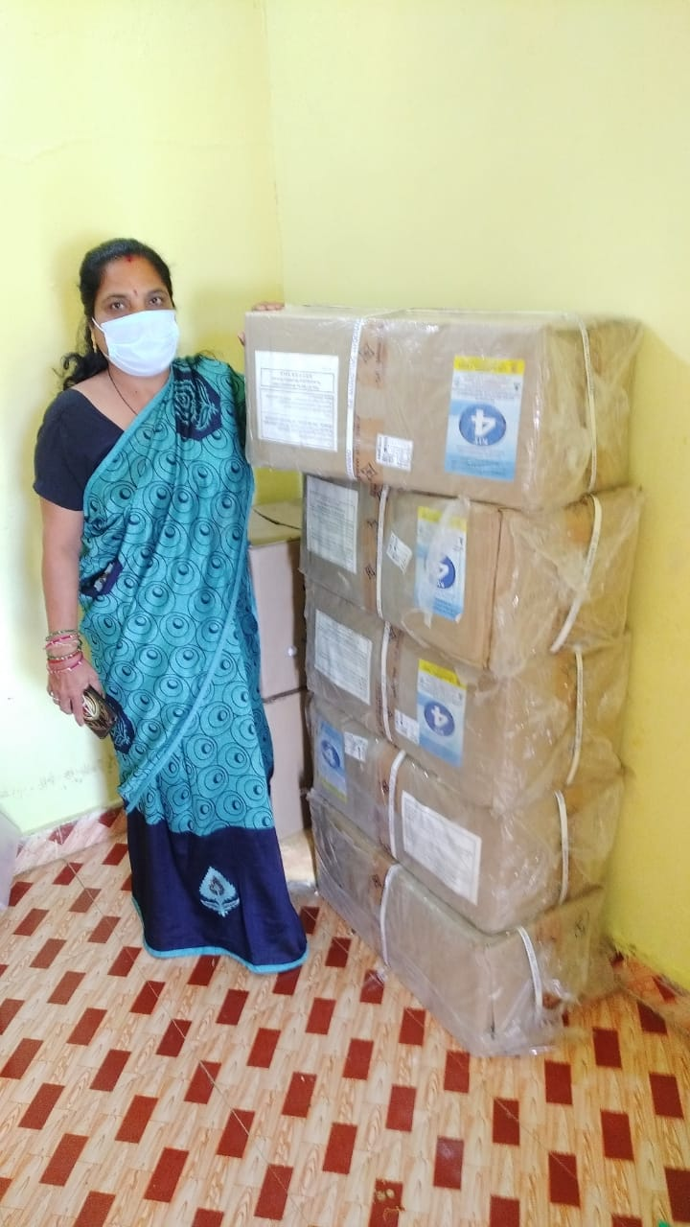
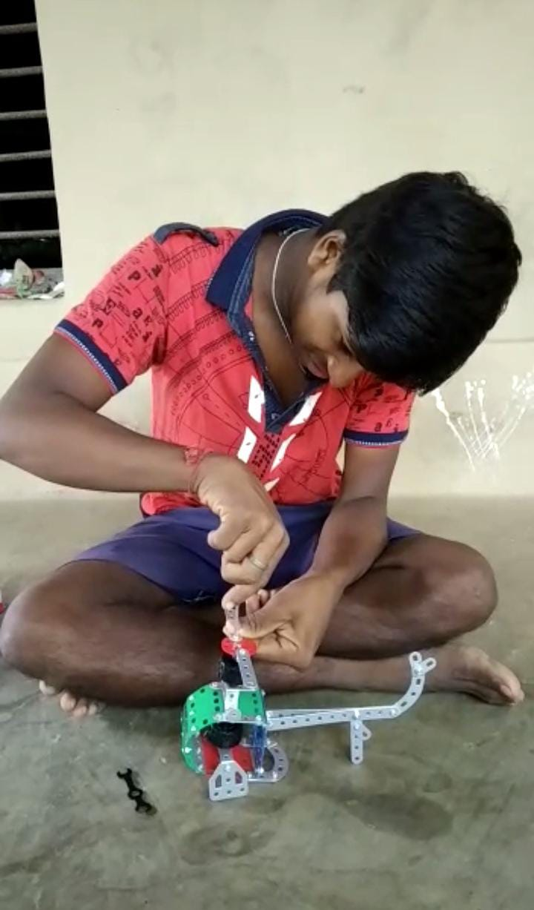
The National Trust purchased and distributed age wise TLM kits to every beneficiary registered under Centre Based Scheme Holders of the National Trust through National Institute for the Empowerment of Persons with Intellectual Disabilities (NIEPID). The total number of 3177 Teaching and Learning Material (TLM) kits have been distributed to the Project Holders of Day Care and Residential Care Scheme Holders. These kits will help the beneficiaries in improving their quality of life. It promotes basic Self-Help Skills, Basic Social- Communication Skills, Functional Reading and Writing and Vocational Skill for facilitating learning among Persons with Intellectual Disabilities.

14.5 Foundation Day of National Trust on 30th December, 2020
The National Trust celebrated its Foundation Day on 30th December, 2020 where Programme Director, Shri U.K. Shukla, Deputy Director, Shri Navnit Kumar were also present with staff members. While celebrating this, not only the road map of National Trust was discussed but how to take the activities of the National Trust forward was also discussed at length.

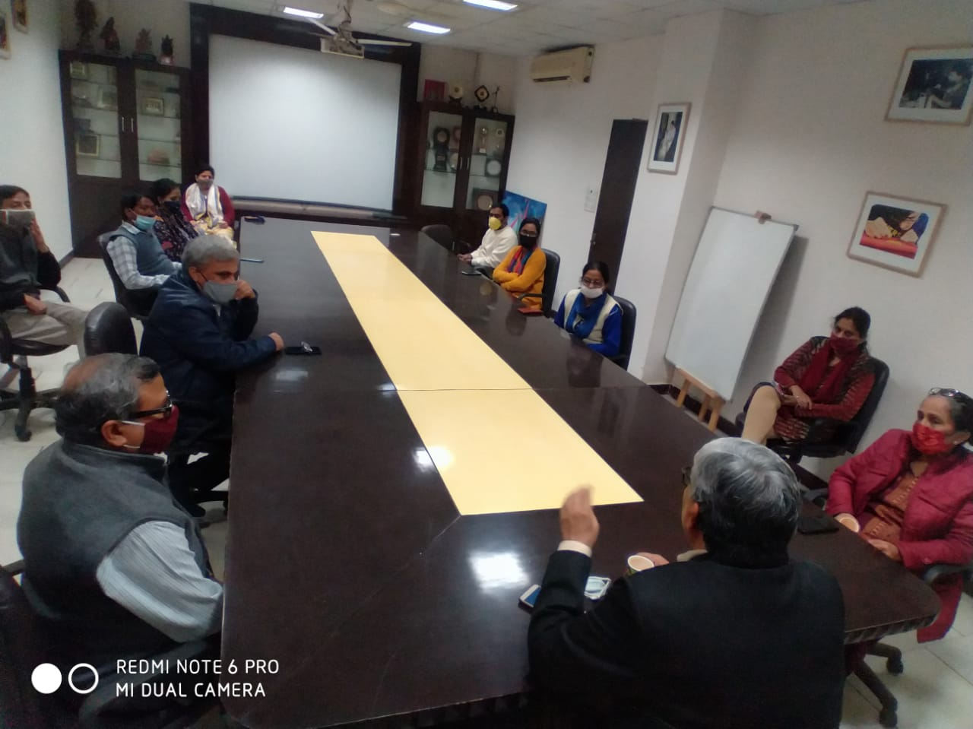

15. Right to Information Act, 2005

The various provisions under Right to Information Act-2005 are being followed by the National Trust. In accordance with it the details of present Appellate Authority and Public Information Officer are as under-
Appellate Authority | Public Information Officer
Sh. U.K. Shukla  Programme Director  National Trust  16-B, Bada Bazar Road,  Old Rajinder Nagar, New Delhi-110 060  Tel. 011-43187804  Email : ala@thenationaltrust.in | Sh. Navnit Kumar  Deputy Director  National Trust  16-B, Bada Bazar Road,  Old Rajinder Nagar, New Delhi-110 060  Tel. 011-43187805  Email : po@thenationaltrust.in

Under RTI Act, during 2020-21, the National Trust received 21 RTI applications offline and 88 RTI applications through online Portal. 5 Online and 1 offline Appeals have been received during this year. All the applications and appeals have been disposed off within time frame.

16. Disclaimer
In case of any difference/anomaly regarding the contents between the Hindi & English Report, the English version shall be accepted/prevail for drawing any inference.

ANNUAL ACCOUNTS
2020-21
(Separate file)



